**The Doodle Bobs Inc.**

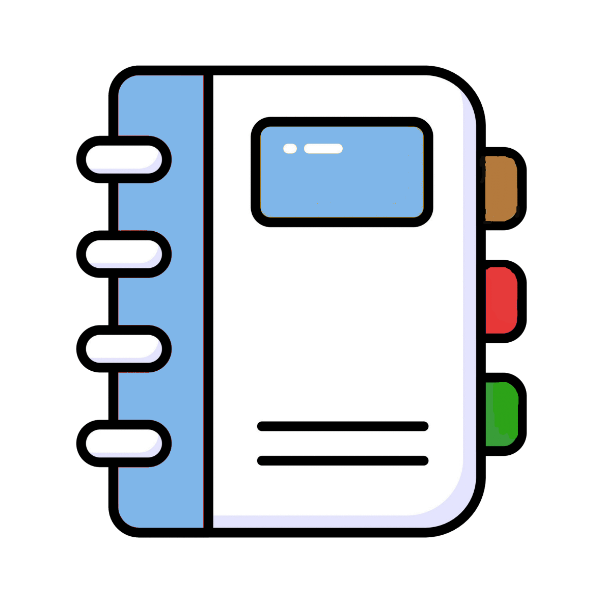

The

Jelly Pages



USER MANUAL

TABLE OF CONTENTS

______________________________________________________________________________________________________________________________

Introduction 2

Ways To Search 3

Emailing 4

Creating Your Profile 5

EDITING PROFILE 6

DETAIL VIEW RESIDENT INFORMATION 6

DELETING PROFILE 7

# Introduction

Welcome to the user manual for the Jelly Pages! This document is intended to provide you with all the information you need to get started with and quickly show you how to get in contact with other Bikini Bottom residents.

When you proceeding to the Jelly Pages website you will be greeted with this screen:

The following instructions will show you and further explain how to utilize and quickly use the phonebook by using features such as:

* 1. Searching for a resident
  2. Creating your profile
  3. Editing your profile
  4. Deleting your profile.

GETTING STARTED

# Ways To Search

1. Use the **search bar** and type in a name, street name, address number, phone number, or email address.
   1. Once you type in the information you have you can either hit the “enter” button on your keyboard OR you can use the green “**filter button**” next to the search bar.
   2. Use your backspace button on the keyboard to erase a previous search OR you can use the “**Search again**” button next to the filter button to clear the search bar.
2. Click on the **column titles** to sort the information in ascending or descending order.

(i.e., first name, last name, address (will sort by address number, not street name, phone number, or email address).

**Email Link**

**Search Bar**

**Column Titles**

**Filter/Search Again Buttons**

# Emailing

From this page you quickly **email** a resident by clicking on their email address. This will automatically open a new email window for you with their email address already added.

**Email Link**

This is what it will look like:

youremail@youremailservice.com

# Creating Your Profile

1. Select the “**Create New Resident**” button from the home page.

**Search Bar**

1. Fill out the form 100%. If you leave any information unfilled you will not be able to save your information. The application will display a red **error message** to let you know what you missed or did not fill out correctly.
2. Click the “**Create**” button when you’re done.
3. You can use the “**Back to List**” button to exit out without filling in information.

**Error Message**

**Back to Homepage**

**Create**

# EDITING PROFILE

1. Select the “**Edit**” button next to your name on the home page.



1. From this window you can edit any of the displayed information.
2. When you are done click the “**Save**” button or the “**Back to List**” button to exit without saving.

**Save**

**Back to Home Page**

# DETAIL VIEW RESIDENT INFORMATION

You can see a card view of resident information by clicking the “**Details**” button on the homepage.



**Details**

You can edit information from this window by clicking “**Edit**”. This will take you to the edit screen or you can click “**Back to List**” to go back to the home page.

**Edit**

**Back to Home Page**

# DELETING PROFILE

1. Select the “**Delete**” button next to your name on the home page.



**Delete**

**Back to Home Page**

1. If you have verified that you have the correct profile you want to delete, click the “**Delete**” button, otherwise click the “**Back to List**” button to exit without deleting.